Department of Computer Science & Engineering

Final Year B. Tech. (CSE) – I: 2022-23

Cryptography & Network Security Lab

**Assignment No. 14**

PRN: 2019BTECS00014

NAME: Siddhi Lokhande

BATCH: B5

---------------------------------------------------------------------------------------------------------

**Title:** Digital Certificate Generation

**Aim:** To Demonstrate Digital Certificate Generation using keytool

**Theory:**

Digital certificate is issued by a trusted third party which proves sender’s identity to the receiver and receiver’s identity to the sender. A digital certificate is a certificate issued by a Certificate Authority (CA) to verify the identity of the certificate holder. The CA issues an encrypted digital certificate containing the applicant’s public key and a variety of other identification information. Digital certificate is used to attach public key with a particular individual or an entity.

Digital certificate contains:-

Name of certificate holder, Serial number which is used to uniquely identify a certificate, the individual or the entity identified by the certificate, Expiration dates, Copy of certificate holder’s public key, Digital Signature of the certificate issuing authority.

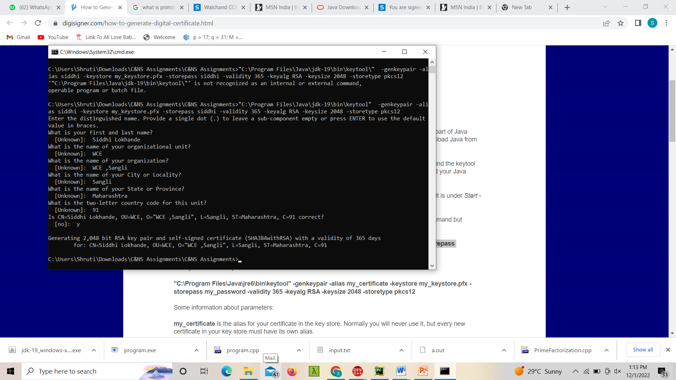

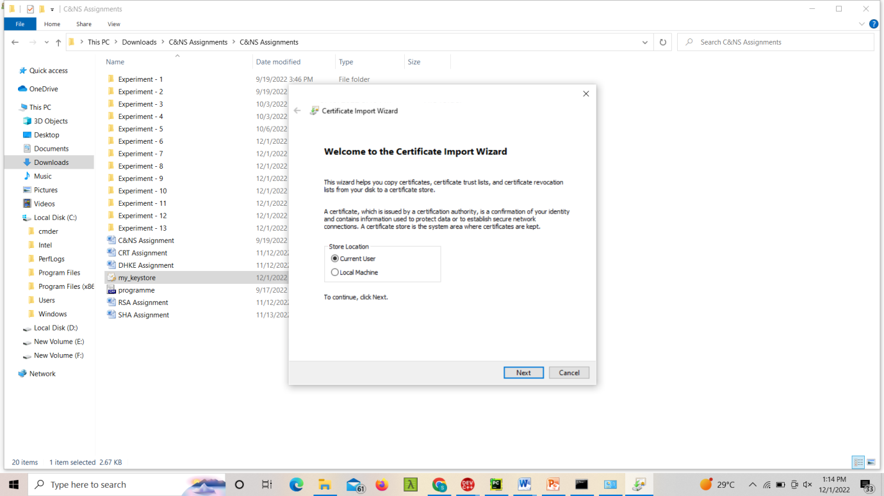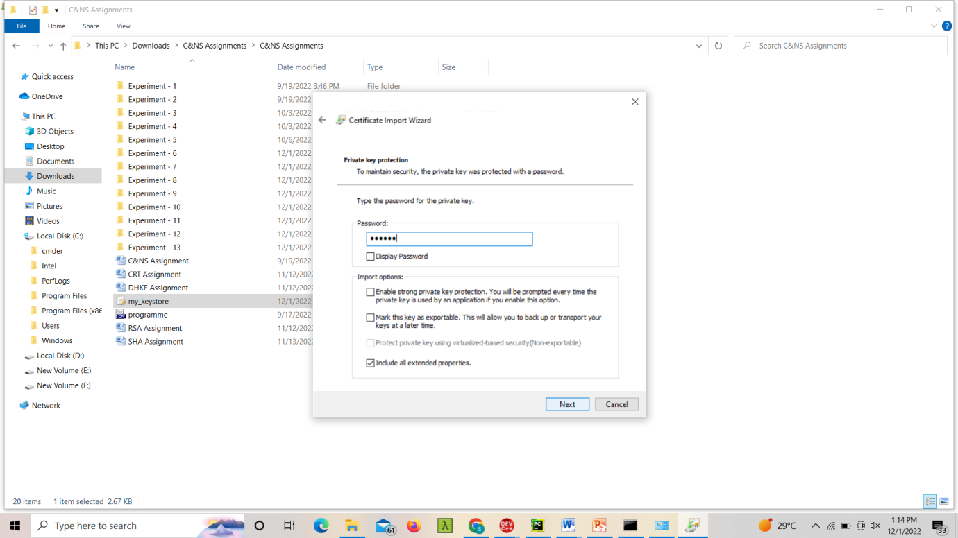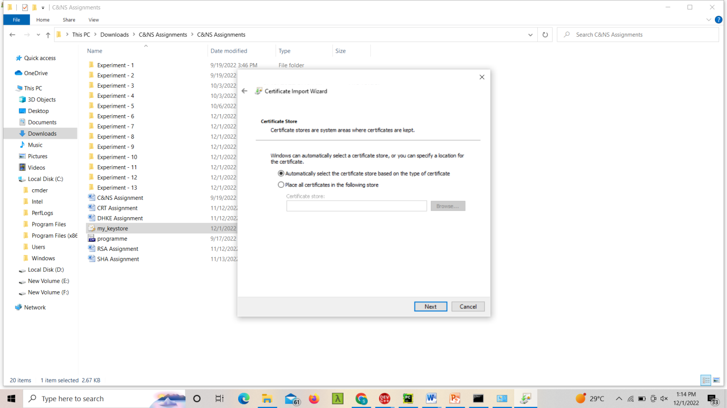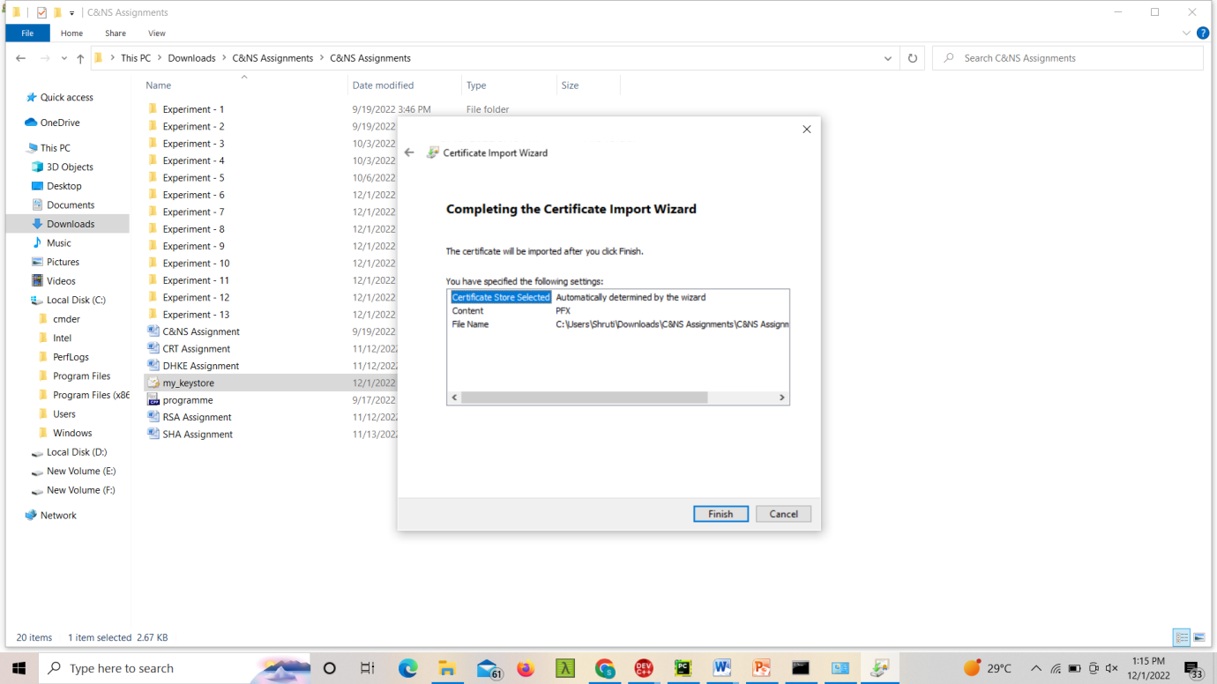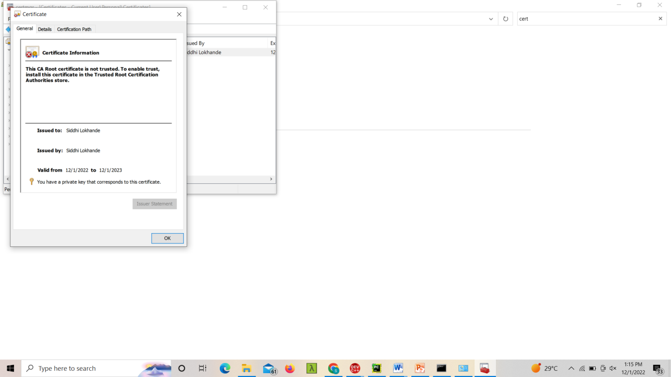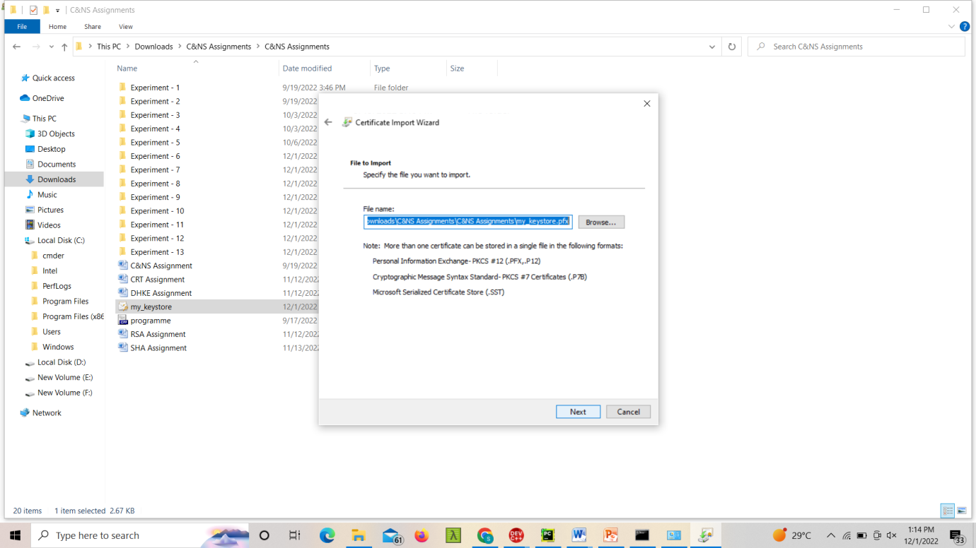

**Conclusion:**

Performed digital signature creation and understood the importance of digital certificate.